23

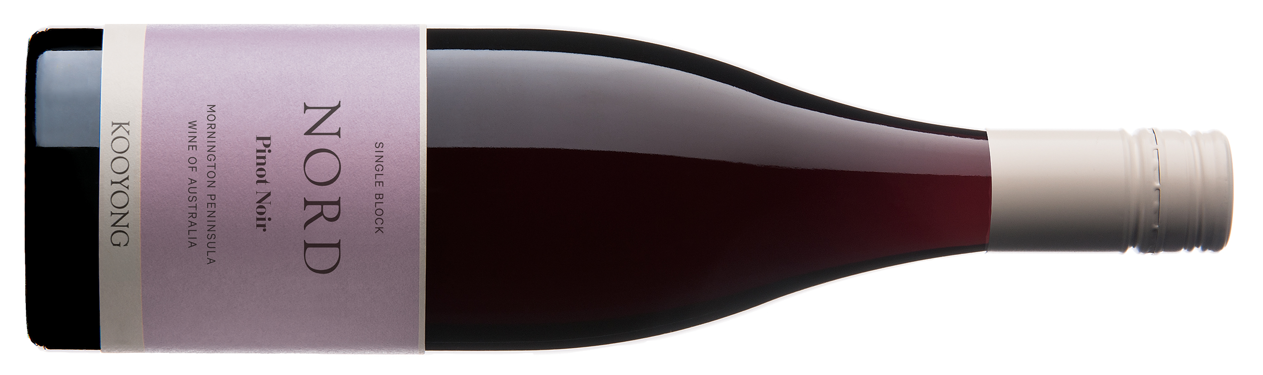Jancisrobinson.com, March 2025

Tamlyn Currin

A brand-new wine, from newer plantings (15 years old) planted at double vine density, 4,500–5,000 vines/ha. Densely planted vineyards 'hit their straps faster, limiting yield per vine by natural means'. 15% whole bunch. Spontaneous fermentation in wooden vat. Inaugural release. Smells like membrillo! So much more intensity. This is vibrant! Denser texture; spicier; plush. Quince, ferrous undertones, notes of smoky chilli, deeper timbre. Vibration and sumptuousness. Fabulous. And very different to the other Kooyong Pinots. Quite a bit more showy, but in a compelling way.

17.5 points

Wine Pilot, July 2025

Jeni Port

This is the inaugural release of fruit from this single block, the vineyard’s most northern. It’s a bit of a charmer. Shows a wealth of the kind of dark cherry, red fruits that define Mornington Peninsula pinot and, in a cool year like 2023, they shine with an attractive purity. Aromas combine the earthy and leafy with the ripe fruited: undergrowth, leaf, earthy dusty beetroot, cassis and cherry, vanilla, red liquorice and a splash of blood orange. It is bright, rose and cherry fresh with layers of firm, concentrated flavour. Shows a pinot of ripeness and freshness with some lovely orange peel and pomegranate touches that really lift in tandem with some crunchy acidity. All round delicious AND worthy of some time in the cellar.

94 points

The Real Review, July 2025

Huon Hooke

Deep red purple colour, bright and vibrant. Rich, ripe black-cherry aromas, a lacing of dried herbs, the palate rich and full, with amplitude and succulent depths of sweetly ripe cherry fruit, quite complex also, and backed with silky-fine tannins that barely impose themselves. A very impressive debut from this new single-block of close-planted vines.

96 points

Halliday Wine Companion, August 2025

Jane Faulkner

A new wine with fruit off the northernmost part of the vineyard (hence 'Nord' in French), planted 15 years ago to a mix of clones, high-density 5800 per ha, but this off 0.8ha, made with 15% whole-bunches, fermented wild in large oak vats, pressed to French barriques and puncheons, 15% new, and aged 12 months. It’s the most fragrant of the single-block wines and, in its way, the most harmonious. Beautifully aromatic with florals, spice and raspberry leaf, flavours of red cherries, pips, a little woodsy/twiggy note. It manages to align savoury elements and sweet fruit very well. Mid-weighted, just, with fine tannins and raspberry sorbet acidity caressing the palate. A lovely wine; impressive debut in a tough vintage.

95 points

The WineFront, August 2025

Gary Walsh

The first release from this close-planted block. Dark cherry and spice, dried flowers, a most pleasing damp earthy stony sort of bass, a suggestion of liquorice and dried orange peel. It’s medium-bodied, a stony feel to tannin, cherry and almond, a juicy freshness to acidity, with a rosehip, pomegranate and red fruited finish of fine length. There’s a little bit of ‘extra’ in this wine, and I’d say it’s the pick of the four single vineyard releases from Kooyong in 2023. Nord. Nice.

94 points